Week 5 Task: Data Visualization
Visual Exploration of Banking-System Indicators
Primary source: World Bank World Development Indicators (WDI)
Continuity: Week 1 EDA → Week 2 Forecasting → Week 3 Risk Analysis → Week 4 Hypothesis Testing → Week 5 Visualization

1. Executive Summary
This report presents a focused data-visualization analysis of banking-system indicators used throughout the financial-data project. The objective is to communicate cross-country differences and relationships more clearly through a set of complementary visualizations. The analysis uses three indicators: bank capital to assets, non-performing loans as a percentage of gross loans, and private-sector credit provided by banks as a percentage of GDP. Five primary charts are presented: ranked capital ratios, ranked NPL ratios, ranked private-credit ratios, a capital-versus-NPL scatter plot, and a private-credit-versus-NPL scatter plot. A correlation matrix is included as a supporting visual summary. The design deliberately uses different chart types for different analytical questions: horizontal bars for ranking, scatter plots for relationships, and a matrix for correlation structure. The purpose is not simply to make charts attractive, but to match each visual encoding to the question being asked and to make comparisons easier for a reader.

2. Dataset and Visualization Objectives
The Week 1 project used a 15-country sample covering developed and emerging economies. The three indicators represent complementary dimensions of banking-system condition: capitalization, asset quality, and credit depth. Week 1 documented substantial cross-country variation, with bank capital-to-assets ranging from 4.07% to 13.73%, NPLs from 0.46% to 5.31%, and private-sector credit from 26.56% to 194.17% of GDP. The observation year was retained because the latest available year differed across countries and indicators.

3. Visualization Design Principles
- Use horizontal bar charts for country rankings because long country names remain readable.
- Sort values before plotting so the ranking can be understood immediately.
- Use scatter plots when the analytical question concerns the relationship between two continuous indicators.
- Label scatter-plot points so individual countries can be identified.
- Keep units in axis labels and use descriptive titles so charts can be interpreted without additional context.
- Use a correlation matrix as a compact summary of linear relationships, while avoiding the implication that correlation proves causation.

4. Visualization 1 — Bank Capital-to-Assets
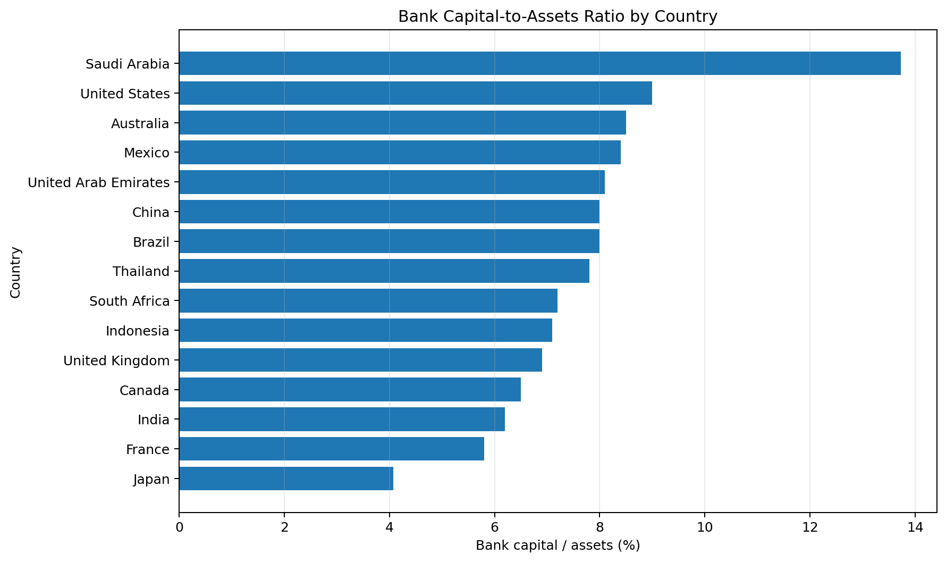
A horizontal ranked bar chart is appropriate because the main question is comparative: how does the reported bank capital-to-assets ratio differ across countries? Sorting the values makes the relative position of each country immediately visible. Higher values indicate a larger capital-and-reserves position relative to total assets, although the ratio alone should not be interpreted as a complete measure of capital adequacy because regulatory definitions, asset composition and risk weights also matter.

5. Visualization 2 — Non-Performing Loans
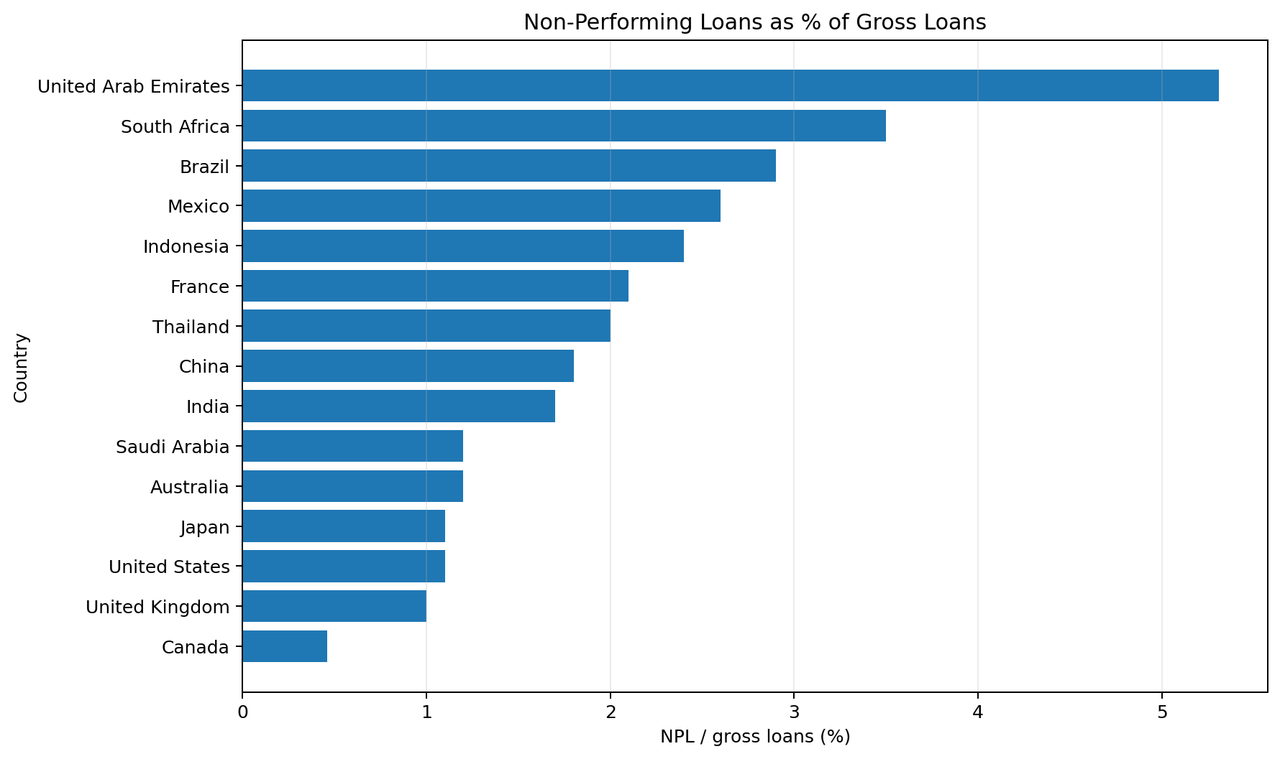
The NPL ranking focuses on asset quality. A horizontal bar chart allows the reader to identify countries with comparatively higher or lower reported NPL ratios. Higher NPL ratios can indicate greater loan-asset stress, but interpretation should consider differences in reporting, loan classification and economic conditions. The chart is therefore most useful as a screening comparison rather than a stand-alone risk score.

6. Visualization 3 — Private-Sector Credit
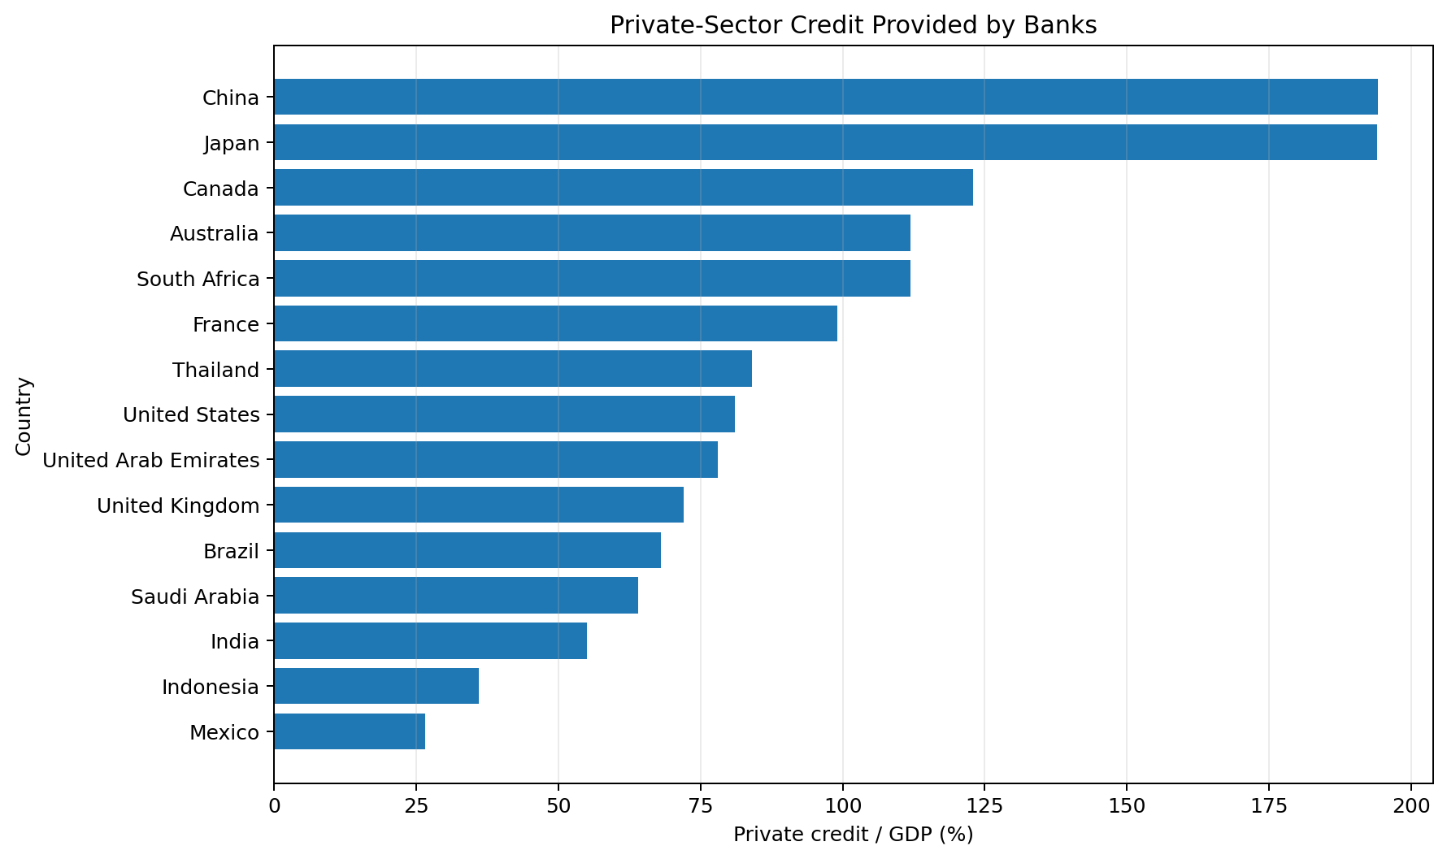
The private-credit chart ranks the depth of bank-provided domestic credit relative to GDP. The measure helps distinguish banking systems with relatively shallow and deep credit markets. A high value is not automatically positive or negative: it may reflect financial development, but excessive credit growth or leverage can also increase vulnerability. This is why credit depth should be considered alongside asset quality and capital.

7. Visualization 4 — Capital vs. NPL
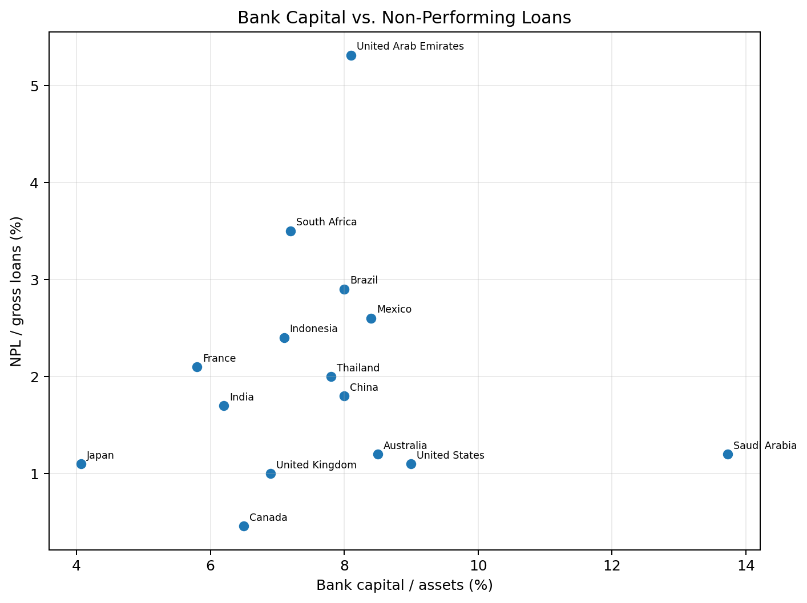
The scatter plot changes the question from ranking to relationship. Each point represents a country, with bank capitalization on the x-axis and NPLs on the y-axis. The visualization helps identify whether countries with different capital positions also tend to have different levels of reported asset quality. The pattern should be treated as exploratory because the sample is small and the observations are not perfectly synchronized in time. A visible association would not establish a causal effect.

8. Visualization 5 — Private Credit vs. NPL
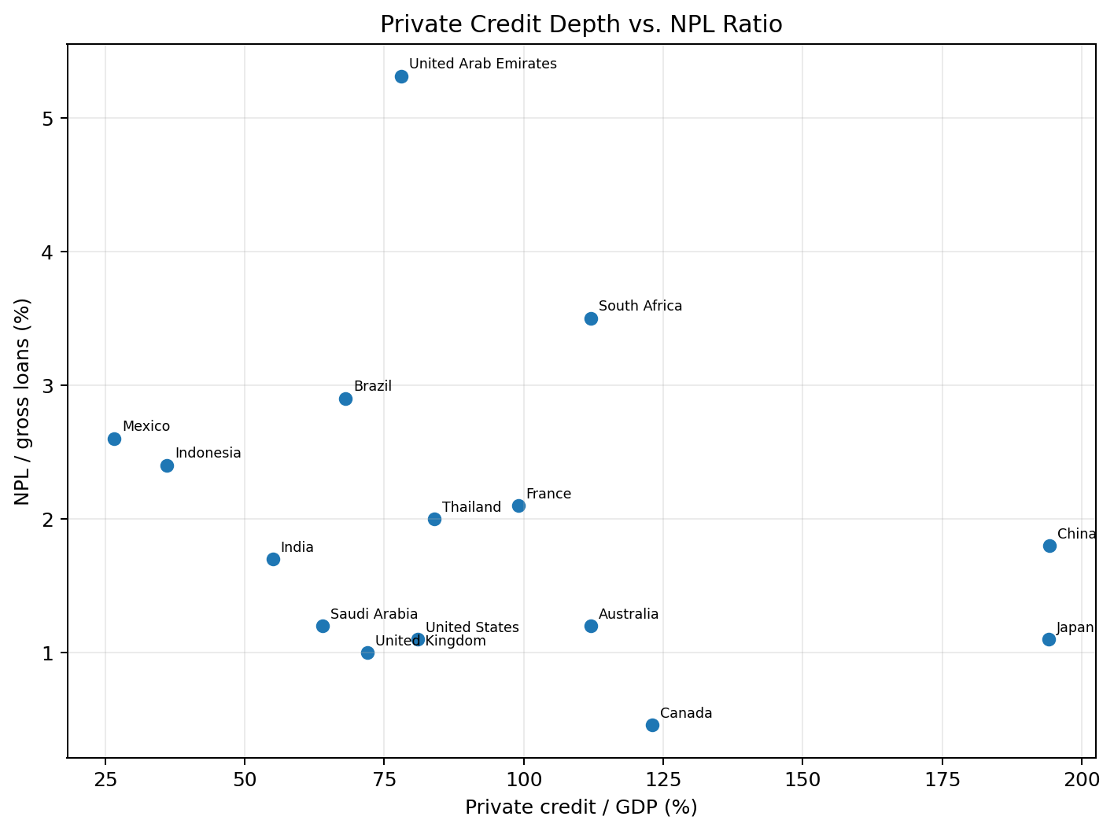
This scatter plot examines whether credit depth and reported NPL ratios appear related across the selected countries. It is useful for identifying outliers and broad patterns that may be difficult to see in separate ranking charts. The chart should not be interpreted as evidence that high or low private credit causes NPLs to rise or fall. Credit quality depends on underwriting, borrower conditions, macroeconomic factors and many other variables.

9. Visualization 6 — Correlation Matrix
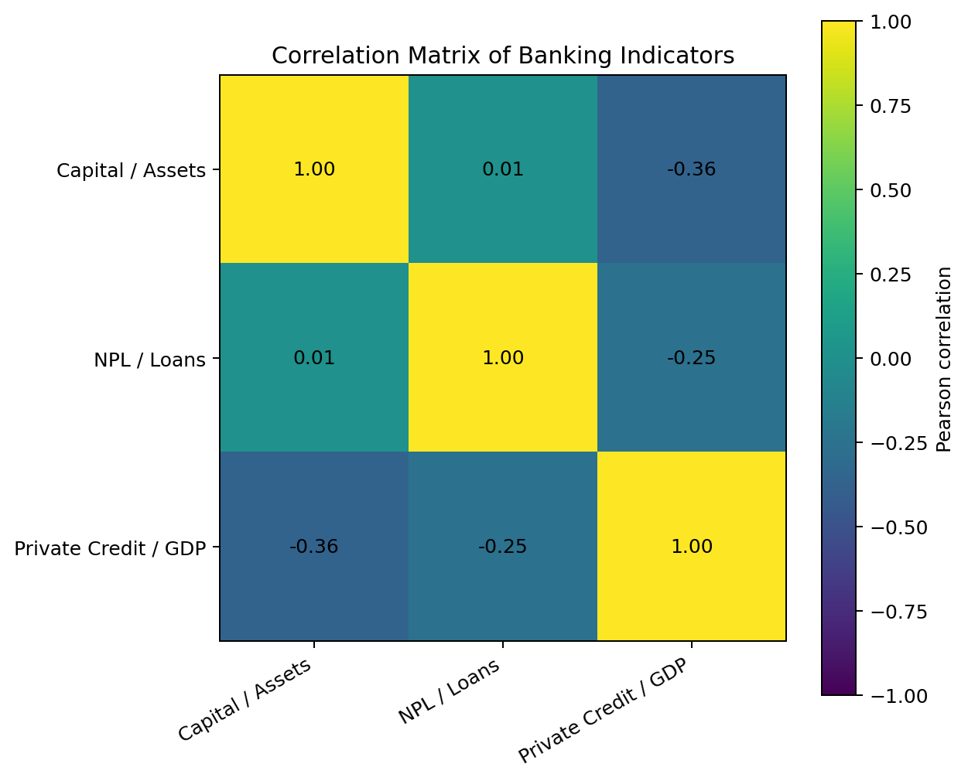
The correlation matrix provides a compact numerical summary of pairwise Pearson correlations among the three indicators. Values closer to +1 indicate a stronger positive linear association, values closer to -1 indicate a stronger negative linear association, and values near zero indicate little linear association in the sample. Correlation is descriptive and does not establish causation.

10. Key Visualization Findings
- The three indicators have very different scales and levels of dispersion, which is why separate ranked charts are more readable than placing all three on one axis.
- NPL ratios show meaningful cross-country differences, making ranking useful for identifying countries that warrant further investigation.
- Private credit has particularly wide cross-country variation, so a sorted chart clearly communicates the difference in banking-system credit depth.
- Scatter plots provide a different perspective from rankings by revealing potential relationships and outliers between indicators.
- The correlation matrix is useful as a compact summary, but it should be interpreted together with the charts and the underlying observation years.

11. Limitations
The visualization sample contains 15 countries, and the latest available observation for each indicator may differ in year. Therefore, cross-country comparisons should be treated as exploratory rather than as a synchronized panel analysis. The charts use aggregate indicators and do not capture bank-level differences, liquidity, profitability, provisioning, macroeconomic conditions or regulatory details. Scatter plots and correlations also do not establish causation. A stronger future dashboard would use a common-year panel and add time-series views, macro-financial variables and interactive filtering.

12. Conclusion
The visualization exercise demonstrates how chart selection should follow the analytical question. Ranked bar charts are effective for country comparisons, scatter plots are useful for exploring relationships between continuous indicators, and correlation matrices provide a compact summary of linear associations. Together, the visualizations make the Week 1 financial dataset easier to interpret while maintaining appropriate caution about data timing, sample size and causal claims.

